**Abstract:** Higher study is a game-changer for students. For a majority of us, studying at a reputable university abroad is an imminent goal. Form a long time there is a tendency for students from developing countries to seek higher education from developed countries. Every year millions of students from Bangladesh also go to study abroad for higher education. Although Bangladesh is a developing country but day by day Bangladesh is also becoming the preferred country of foreign students. But many of them go back to their country without finishing their studies or migrate to our neighboring countries like India and Pakistan. The main purpose of this paper, is whether Bangladesh is suitable for higher education? and those who currently in this country for higher education, are they satisfied or dissatisfied. If they have any problems, what kind of problems are they experiencing and how to resolve them. we will identify the university's problems where they need to improve, so that they can attract more foreign students. For the case of foreign students, we collect data from 399 present foreign students in Bangladesh. This paper used some popular classification algorithms such as support vector machine, KNN, ANN, Random Forest. We also present a comparison of used machine learning algorithms over different evaluation metrics.

**1 Introduction**

Education means a way of learning in which knowledge, skills, and habits are transferred from one generation to the next generation. Education plays a crucial role in a country's reputation around the world and helps in developing the country in every field. If the people of a country are educated then they can easily help them in development. There have three levels of education primary, secondary and higher. Among the three-level of education higher education plays a key role in developing countries to develop the country (education folder).

Now a question arises that what is higher education? The answer is Higher education, any of various types of education given in postsecondary institutions of learning and usually affording, at the end of a course of study, a named degree, diploma, or certificate of higher studies. Within the present-day world, there is another way to seek higher education it’s called e-learning (using the electronic asset computer, internet), which does not require physical classrooms for students. Compared to ordinary modes of learning, e-learning is less expensive, and a greater number of understudies can enlist for online courses. In any case, in e-learning, there's no arrange communication between understudies and teachers. Therefore, e-learning stances several challenges. To start with, it is troublesome for teaches to overview the viability of a course. Minute, the dropout rate of understudies in e-learning courses is much higher than that in ordinary modes of learning. Third, surveying the student’s execution is troublesome. Fourth anticipating at-risk understudies in unused courses is also troublesome.

After World War II, there is a tendency for students from poor and developing countries to seek their higher education from developed countries (Zhao 1996). Now the question is why? Every student wants to go from his current education system to a good education system. The reason is there is a big difference between the education system of the developed country and the education system of the developing country. There is no politics centered on the university, there is no session. There are many opportunities for research abroad. Those who study abroad are far ahead of the general public in terms of independence, self-reliance, intelligence and creative ability. Since leaving their family and living alone in a foreign country, they are self-reliant and skilled in solving problems. Not only that, they are not lacking in any challenging task. By staying abroad, a student will become aware of the politics, culture, customs of that country. In addition, he will have a different view of the world. Learn about the world's political issues Being abroad, he has to learn the language of that country, which will add another pastor to the crown of his experience. Higher education abroad will not only improve the educational qualifications and values ​​of a student, but also increase his professional skills. His demand in the job market goes up. Returning Graduates are rich in international knowledge and proficient in one or more languages ​​besides mother tongue. And these two issues are emphasized by international or multinational organizations. Also, because they have knowledge of the communication skills, different cultures and aspects of the society, as well as new ways of thinking and taking risks, it is possible that the institutions offer the highest level of facilities for the graduates to keep themselves in the establishment.

Every year millions of students are going to overseas to seek their higher study from Bangladesh. Before 1991 there had only eight public universities in Bangladesh. In spite of having the knowledge, there had no opportunity to seek higher study for the limited number of sits. Therefore, the government of Bangladesh took the initiative to set up public universities as well as private universities so that Bangladeshi students can get higher education in the country. After 1991, the private university of Bangladesh started its journey. At present, 42 public universities and 109 private universities in Bangladesh have confirmed the quality of their higher education (UGC report 2018). Currently these universities are studying with Bangladeshi students as well as foreign students (especially south Asia, Africa). In Bangladesh, the number of foreign students is increasing day by day. But after talking to the current foreign student, we found out that due to some problems (could not attend the desired university, cannot afford the cost) some students came to Bangladesh and return to their country without completing their studies. This threatens the student’s carrier. Because the student leaves the country for higher education and spends a lot of money behind it. Therefore, one of the challenges of the present government of Bangladesh is to ensure the safety of foreign students and how to ensure the quality of higher education.

In this study our aim to collect data from current foreign students and analyze what kind of problems they are facing and how to solve these problems. This study will come up affective and cool methods for solving the challenges that foreign students face in Bangladesh. In addition to that, UGC, foreign student’s community, ministry of education of Bangladesh and universities of Bangladesh all they will get primary data about the matter. In addition, the embassies of those foreign will get the point and will tackle the challenges partially. The outcome of this study will be important to the other foreigners (Arrived/will arrive) to Bangladesh to study higher education sectors. Finally, this study will be useful to the researchers by contributing to the body of the knowledge that will create a basis for policy formulation in order to limit and solve the challenges face by the foreign students in Bangladesh. Various machine learning and deep leering techniques are employed for such propose.

Key objective of this study, the following are subsequent research challenges addressed in paper.

The structure of the report is organized as follows.

In the second chapter we have discussed about related work. in the chapter three we have shown our data distribution .in the chapter four we have shown our mythology. In the chapter five we have discussed our result and analysis. In the chapter 6 we have made limitation and future work at the last conclusion and references of the report.

**2 Related Work:**

The process of internationalization in higher education is progressing steadily ().

GEORGE V. COELHO at all (1). In their research, they described the main factors that put foreign students at risk in higher education as a result of the transfer of new cultures and environments. They Mentioned Many complications arise when young people migrate abroad for higher education as they become acquainted with new cultures and environments. So, they have to adapt to that environment as soon as possible to overcome this complication. They highlighted a life cycle of the students and they said that child's first school experience, the junior school transition, the transition from high school to college, graduate student stress, etc. Education overseas may be a major developmental and psychosocial move in a foreign student's life. Like other moves, it represents an arrangement of stages of high-risk situations that deliver emotional push as well as openings for adapting behavior.

C. D. THROSBY at all [7]. They have shown in their research how foreign students play an important role in the economic development of the host country. They described both direct and indirect costs-benefit. They have mentioned tuition fee, accommodation, meals and the costs of any additional services provided, such as special counselling, or host country language courses as a direct benefit. for the indirect benefit, they point out that local students can become acquainted with a wide variety of cultures, and that foreign students take the research sector further by participating in research. Similar to these benefits There are some possible parallel costs such as enmity from local students, unpleasant reaction by foreign students to the host institution, etc.).

There have been a few endeavors to measure the total benefits and costs of foreign students in host countries (for example, Reubens 1975; Blaug 1981; Jenkins 1983; Winkler 1983; Chishti 1984; Fry 1984; Manning et al. (Collection folder)

Every country follows some foreign policy for foreign student. According to (6) Prior to 1986, about 45 to 60 per cent of foreign students in Australia were studying on scholarships. As a result, the Australian government had to pay a large subsidy every year. In 1986, the government of Australia issued a proclamation to all educational institutions in their country, asking all educational institutions to declare their course as fully paid for foreign students. As a result of the Australian Government's decision, students from many developing countries, despite their qualifications, were barred from pursuing higher education in Australia. To address this problem, the Australian government introduced the Merit Scholarship in 1990. Within 4 years of this rule, the number of foreign students in Australia increased from 24,000 to 55,000, of which 30,000 were fully paid [6].

Nowadays machine learning algorithms have become very popular in research. At present machine learning techniques are being used to solve other problems as well as the problems of educational institutions such as institutions, teacher quality (Góes et al. 2014; Xiao-YanLiu 2015), examination and assessments (Muklason et al. 2017), measure practices impact (Delen et al. 2013), learning product selection (Alptekin and Ertugrul 2010; Oztekin et al. 2013), course planning (Abdahllah 2015) and more.

According to Acharya A, Sinha D (2014) at all. Developed a model using machine learning to predict student’s performance. They have mentioned the academic performance of students depends on previous academic records, economic status, family background, performance in mid semester examination. Based on these factors they apply Decision Tree (DT). Bayesian Networks (BN), Artificial Neural Networks (ANN), Support Vector Machines (SVM)(8).

Tan M, Shao P (2015) by using Artificial Neural Network (ANN), Decision Tree (DT) and Bayesian Networks (BNs) developed a model to predict the dropout of student in eLearning program.

Although some of these studies addressed educational problem issues at the higher education level, none have considered the satisfaction and dissatisfaction on host country. While previous research focuses on prediction, the most commonly used algorithms are artificial neural networks and support vector machines. Some authors, including ourselves, go further into comparing these algorithms’ performance. After revising other articles that had different goals, we learned of other machine learning algorithms that have been used, such as linear regression, logistic regression, random forest, adaptive boosting and others.

**3 Methodology:**

Our proposed framework for identification of satisfaction or dissatisfaction students (Fig. 1). We then apply supervised machine learning approaches to study each factor types independently. The classification techniques such as ‘decision Trees’, ‘k-Nearest Neighbor’, ‘Support Vector Machine’, and Random Forest.

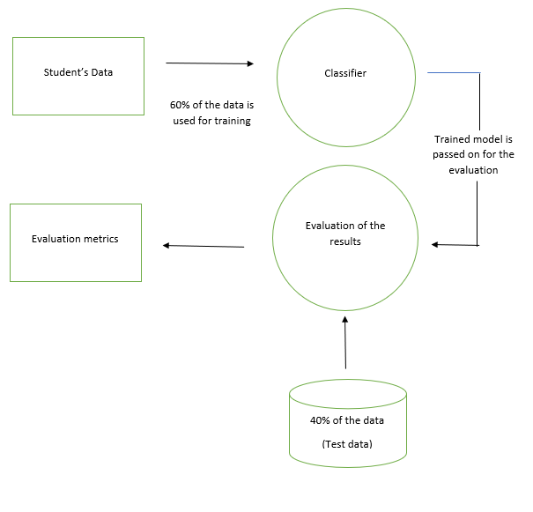

**Fig.1 Architecture of our proposed model**

**3.1 Data collection:** we have collected data from foreign students studying is Bangladesh (daffodil university, independent university, Dhaka international university, City university, Asian university). the dataset contains the current situation of foreign students. this dataset contains 25 columns where each column speaks to a special piece of data about a foreign student. since every column provides valuable information for satisfaction of dissatisfaction of foreign students so in this paper, we selected all 25 columns. generally, these columns contain both "satisfied" and "dissatisfied" foreign students’ information. the dataset contains 500 rows and 25 columns based on the following questions which are shown below.

1 It’s easy to visa processing from your country to Bangladesh?

2 After coming to Bangladesh are you face any complexity of visa?

3 Is it easy to send money from your country to Bangladesh?

4 Do you feel safe in Bangladesh?

5 Has the government of Bangladesh given you any insurance?

6 do you satisfied with the accommodation in Bangladesh?

7 Bangladeshi classmates are friendly?

8 are Bangladeshi teachers friendly and helpful?

9 are General people of Bangladesh friendly?

10 are Bangladeshi police helpful?

11 Do you have to pay any tax in Bangladesh?

12 Can you use mobile banking in Bangladesh?

13 In Bangladesh are you a victim of racial decimation?

14 do you face any problem with food?

15 do you face any problem with changing climate?

16 do you face any political problem?

17 do you face any corruption?

18 do you face any problem with the Bangladeshi education curriculum?

19 Are you satisfied with the health service of Bangladeshi hospitals?

20 Do you enjoy the festivals of Bangladesh?

21 do you face any problem on the first meeting?

22 Can you buy any vehicle in Bangladesh easily?

23 Is there any problem to celebrating the own religion?

24 do you face sexual harassment?

25 what is your gender?

**3.2 Ground Truth Dataset:**

This segment talks about the method utilized to develop our dataset with ground truth label information (on whether the foreign students satisfied or dissatisfies). we use our dataset and split it into two sets (1) for the positive (YES) class (satisfies) and (2) for the negative (NO) class (dissatisfied). we defended the data in each set physically using three specialists. we analyzed around 500 records of foreign students where 80% gotten yes and 20% gotten no. Table 1 outlines the outline of foreign students.

|  |  |
| --- | --- |
| Total number of students | 399 |
| Satisfied students |  |
| Dissatisfied students |  |

**3.2 classification model:**

The machine learning classification has two steps, one is the learning step and the other is the prediction step. Learning data is provided to teach the machine and data is provided to predict the prediction step.

This stage develops a prediction model for satisfaction/dissatisfaction recognition, by considering the features as input. considering our preparing corpus B = p1, p2......pn on n students’ data, such that each information pi is labeled with the class either satisfaction or dissatisfaction, where l – l1|l2. the task of classifier f is to discover the corresponding label for each student data.

*f: B $∈$ L f(p) = l*

in this work, we employ five well-known classifiers: support vector machine (SVM), Decision Tree, k-nearest neighbor (KNN), artificial neural network (ANN) and random forest (RF).

**3.2.1 Artificial Neural Network:**

Network means basically a set of node where node is connected to each other in some way (directly or through anything). A neural network is a network of neurons where neurons are interconnected and can exchange information with each other. the neurons are arranged in one or more layers. The calculation of data is done according to the layer and information is exchanged from one layer to another. Below is a picture of a very common neural network.

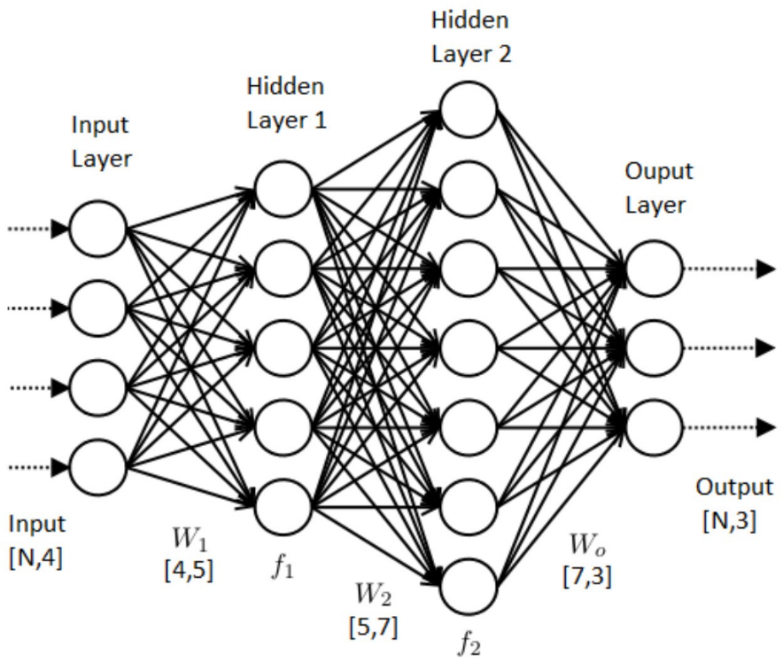

**Figure 2. Artificial Neural Network.**

The layers are classified into three categories namely the input layer, hidden layer, and output layer. The connections between neurons connection are assigned specific weight. The connections between neurons correspond to a few weights. So, training a neural network involves altering all those weights such as in the case given an input after performing all the calculations it gives the proper output. In this backpropagation algorithm first, we go in one way from input to output and after that propagate back from the output to input adjusting weights. There's too a bias unit whose weights are balanced. And at last, an activation function is used to get the proper output according to the training set. The backpropagation is rehashed until the error is decreased to a really little esteem. The multilayer perceptron is more advantageous with features like non-linear mapping and noise tolerance. It is more used in data mining since of its great behavior with respect to predictive knowledge

**3.2.2 support vector machine:**

Support vector machine is supervised learning model. It is used in classification and regression machine learning problems. the main goal of SVM is to separate the classes by drawing a hyper line with the highest margin between the two classes. Notice the figure below, the points of the two classes closest (‘solid round’ ‘solid square) of them are called support vectors. the distance between these support vectors is called the margin. The higher the margin, the less likely the points are to be misclassified. Because the closer the points of two different classes are, the more likely they are to overlap. Supported vector machine help to decipher boundary and margin. Other points of a class are not as important as the classification, except for the support vectors. if there are two hyper plans in which A can properly classify the two-class, but the margin is very low. on the other hand, the margin of B is too high but there are some errors. A will be selected. This higher dimensional dividing is known as the SVM kernel and can be defined by any mathematical surface. A few of the more common kernels are linear, quadratic, polynomial and Gaussian radial basis function.

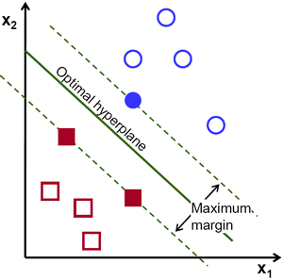

**Figure 3. Support vector machine.**

**3.2.3 K-Nearest Neighbors:**

K-Nearest neighbor algorithm (k-NN) is a non-parametric and lazy (training is not required) method. it is a supervised machine learning algorithm. K-Nearest neighbor algorithms (k-NN) can solve both classification and regression problems. The ‘k’ in KNN algorithm is the number of nearest neighbors taken into consideration. In this model, the value of k has determined by the square root of the total data.

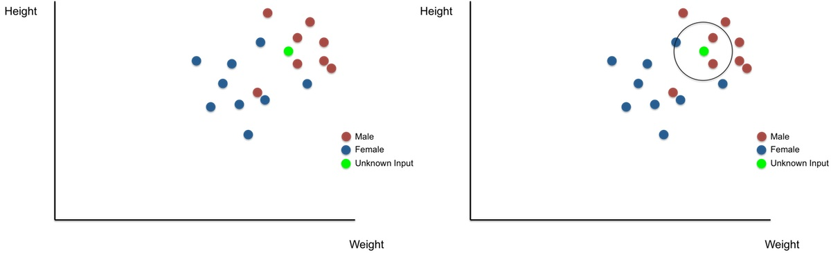

**Figure 4. Before k-NN Classification Figure 5. After k-NN Classification**

Figures 2 & 3 show the scenario before k-NN classification and after k-NN

classification.

Here, ‘unknown’ has to be put in one of the two classes – ‘Male or

‘Female. With Unknown input as center and radius sufficient to encircle 3 nearest neighbors

(k=3), a circle is drawn. Class of unknown input is defined based on the majority.

The four main step of the algorithm are: -

* All other data points must be calculated from unknown data points.
* Ascending or descending orders should be resorted according to the distance standard.
* The first k is to take the data points from the sorted data points.
* Unknown data point should be identified in that class as the number of data points in which this class has the highest number of times.

**3.2.4 Decision Tree:**

Decision tree is supervised learning algorithms. It can be used for solving regression and classification problems too. in this algorithm, data is split by a particular node. a child note is created after each value is split. if the subset of each child node is the target value then it will stop otherwise recursive split will occur. this algorithm uses an algorithm called ID3 to select the root note and adjust the order of intermediate notes. the id3 algorithm uses the greedy method approach to get a decision tree that returns the highest information gain or minimum entropy. **Entropy:** entropy is, if a dataset is partitioned against a feature, then how well that partitioning can partition the target variable's column

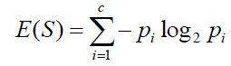

**Gain:** Information gain is based on the decrease in entropy after a dataset is

split on an attribute.

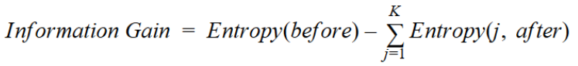

**3.2.5 Random Forest:**

Decision tree is supervised learning algorithms. It can be used for solving regression and classification problems too, it is mainly used for classification problems. Forest means the sum of many trees. Similarly, random forest is the sum of many decision trees. Random Forest completes its tasks by following the steps below: -

* To begin with the selection of random samples from a given dataset.
* Following, this algorithm will develop a decision tree for each sample. At that point, it will get the prediction result from each decision tree.
* At the last stage, it will take result depending upon the majority voting.

**4 performance evaluation:**

The purpose of this paper is whether Bangladesh is suitable for higher education and those who currently in this country for higher education, are they satisfied or dissatisfied. for this, we have used some popular classification algorithms, such as support vector machine (SVM), Artificial Neural Network (ANN), K-Nearest Neighbor (KNN), Decision Tree (DT) and Random Forest (Rf). and we used some performance metrics to evaluate the performance of these algorithms. These metrics include Recall, False Positive rate (FPR), F-measure, Accuracy and Precision.

A confusion matrix is an easy way to calculate algorithm performance. where the output can be of two or more types of classes. confusion matrices are two-dimensional matrices, dimensions are 'Actual', 'Predict' and more, each dimension have “True Positives (TP)”, “True Negatives (TN)”, “False Positives (FP)”, “False Negatives (FN)” as shown below –

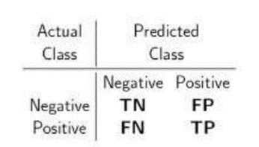

Accuracy means calculating how many accurate predictions an algorithm can make (TP and TN).



precision means the ratio of the number of positive predictions to the number of positive predictions the algorithm ha made.



Recall is the ratio of true positives to the cases that are actually positive. It is the percentage of corrected cases that are selected.

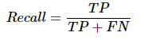

F-measure is the harmonic mean of precision and recall.

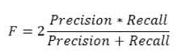

**5 Results and Discussion:**

we have collected data from foreign students studying in Bangladesh to build the model. we have split the data set into 60/40, in which 60% of the data set has used for the tasting model and 40% of the data has used for the testing model. five popular classification algorithms have been used, such as SVM, ANN, KNN, DT, RF. First, KNN classification is used with k value as 1. The training model is built with 60% of the dataset. and KNN produces 80% Accuracy. to train SVM we have used 60% data. and we have used kernel is linear, because our data have only two class "satisfaction" or "dissatisfaction". SVM produces 95% accuracy. Next, the Artificial neural network model is built using a multilayer perceptron and it also used 60/40 split of data. we have used 100 hidden layers. among the five algorithms, ANN gave the highest accuracy it produces 98% accuracy. the remaining two algorithms decision tree and random forest give 92% and 94% accuracy, respectively.

**Table 2: Performance of Classifiers**

|  |  |  |  |  |
| --- | --- | --- | --- | --- |
| Algorithms | Accuracy | Precision | Sensitivity | Specificity |
| SVM | 0.94 | 0.93 | 1.0 | 0.98 |
| RF | 0.90 | 0.65 | 1.0 | 0.84 |
| DT | 0.83 | 0.86 | 0.88 | 0.94 |
| KNN | 0.85 | 0.59 | 1.0 | 0.85 |
| ANN | 0.80 | 0.92 | 0.80 | 0.78 |

**6 Conclusion**